**Guidelines of Project Schedule Development**

# I. Overview

## 1. What is project schedule?

The project schedule outlines the tasks and activities of the project; the duration; start and end dates for each individual task and the project as a whole; and the resources and effort required.

## 2. Project scheduling process

Developing a project schedule involves a number of defined steps.

* Develop WBS
* Define Work Packages
* Define the activities or tasks
* Sequence Project Activities
* Estimate activity resource
* Estimate activity duration
* Develop Schedule

For most projects there will be at least two separate schedules developed. One will be for the Initiation phase (high level project schedule) and the other (detailed project schedule) for the Planning, Execution, Monitoring & Controlling, and Closure phases. All schedules can be developed and maintained using scheduling tool (Microsoft Project, Project Libre, Microsoft Excel, etc.)

The high level schedule is developed in the Initiation Phase of the project to help produce the Project Charter. At this point, the Schedule is not expected to be very accurate or contain firm dates; rather it just mentions the main project milestones & gives the Project Manager (PM) a rough idea of the project timeline and the assignment of resources.

When the Charter is approved, the detailed project schedule is developed – based on the high level project schedule, with the approval date as the Project “start date”.

In the Planning Phase, a Project Management Plan is created (from the Charter), and the detailed project schedule is updated with a more detailed, accurate and realistic timeline.

A process flow diagram outlining detailed steps in completing a Schedule is as below



# II. Project Scheduling Steps

## 1. Develop WBS

The WBS (Work Breakdown Structure) provides a clear description of the project’s deliverables. It describes the “what is to be done” not the process or schedule. Therefore, the WBS:

* Is a deliverable breakdown structure
* Is a hierarchical decomposition of the work – the deliverables are decomposed to a level where a  
  work package can be defined (see work package below)
* Is a graphical representation or textual outline of the project scope
* Represents 100% of the work defined by the project scope and captures ALL deliverables,  
  internal, external, and interim, including project management

The WBS helps:

* Develop the work packages
* Define the project tasks
* Develop the schedule
* As a tool to communicate the project to stakeholders

An example of a Work Breakdown Schedule is as below

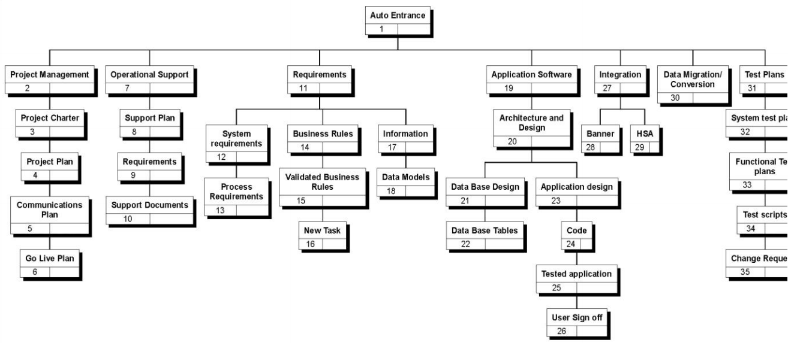

## 2. Define Work Packages

Work packages are the lowest level in a WBS decomposition where an activity duration can be reliably  
estimated and managed. A Work Package can be created where a Project Manager (PM) deems it  
necessary to help develop the project Schedule.

A work package details a level of work to be completed. It would contain a description of the work,  
details of constraints, and agreement between the PM and the team or individual doing the work, that the  
work can be done within the constraints. Assumptions would be defined in the work package depending  
on the needs of the project.

Work packages are particularly useful where contractors or other departments are involved in the project.  
A work package should define durations of 4 to 6 weeks. The PM would assign the work package and  
authorize the work to be completed according to the project Schedule. The PM would monitor and control  
the project at the work package level and not necessarily at the task level.

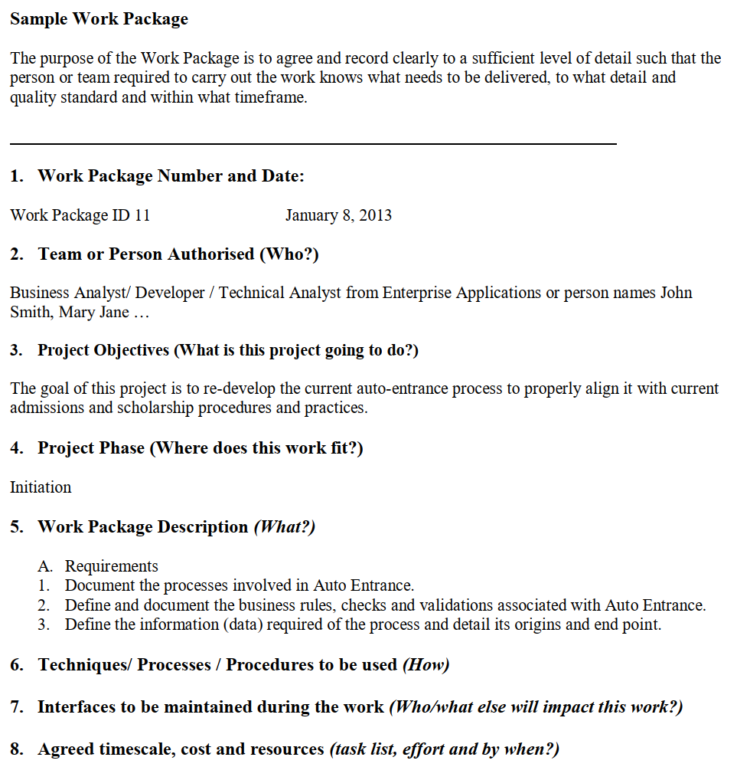

## 3. Define Activities or Tasks

Activities/Tasks are the lowest level of work defined in a schedule. A task is the work to be done and contains a description, the start and end dates, the resource assigned to work on the task and any dependencies on other tasks. Task duration should be 1 to 3 days but no more than 5 days of effort in order to allow progress to be controlled & measured.

Activities/Tasks are usually defined by the person who will perform the task. The Project Manager, Resource Manager and others who have knowledge of the work required, would be involved with identifying the tasks and the tolerances for how long they will take using the estimation.

The project team reviews the schedule management plan, scope baseline, enterprise environmental factors, and organizational process assets to begin defining activities. Outputs of this process include an activity list, activity attributes, a milestone list, and project management plan updates.

The activity list is a tabulation of activities to be included on a project schedule. The list should include the activity name, an activity identifier or number, and a brief description of the activity. The activity attributes provide more schedule-related information about each activity, such as predecessors, successors, logical relationships, leads and lags, resource requirements, constraints, imposed dates, and assumptions related to the activity. The activity list and activity attributes should be in agreement with the WBS and WBS dictionary. Information is added to the activity attributes as it becomes available; this information includes logical relationships and resource requirements that are determined in later processes. Many project teams use an automated system to keep track of activity related information.

A milestone on a project is a significant event that normally has no duration. It often takes several activities and a lot of work to complete a milestone, but the milestone itself is like a marker to help in identifying necessary activities. Milestones are also useful tools for setting schedule goals and monitoring progress. For example, milestones on a project like the one in the chapter’s opening case might include completion and customer sign-off of documents, such as design documents and test plans; completion of specific products, such as software modules or installation of new hardware; and completion of important process-related work, such as project review meetings and tests. Not every deliverable or output created for a project is really a milestone. Milestones are the most important and visible events. For example, the term milestone is used in several contexts, such as in child development. Parents and doctors check for milestones, such as a child first rolling over, sitting, crawling, walking, and talking.

You cannot determine activity sequencing, resources, or durations, develop the schedule, or control the schedule until you have a good understanding of project activities.

The goal of defining activities is to ensure that the project team completely understands all the work it must do as part of the project scope so the team can start scheduling the work. For example, a WBS item might be “Produce study report.” The project team must understand what the item means before team members can make schedule-related decisions. How long should the report be? Does it require a survey or extensive research to produce? What skill level does the report writer need to have? Further defining the task will help the project team determine how long it will take to do and who should do it.

The WBS is often dissected further as the project team members continue to define the activities required for performing the work. For example, the task “Produce study report” might be broken down into several subtasks describing the steps of producing the report, such as developing a survey, administering the survey, analyzing the survey results, performing research, writing a draft report, editing the report, and finally producing the report.

As stated earlier, activities or tasks are elements of work performed during the course of a project; they have expected durations, costs, and resource requirements. Defining activities also results in supporting detail to document important product information as well as assumptions and constraints related to specific activities. The project team should review the activity list and activity attributes with project stakeholders before moving on to the next step in project time management. If the team does not review these items, it could produce an unrealistic schedule and deliver unacceptable results. For example, if a

project manager simply estimated that the “Produce study report” task would take one day and then had an intern or trainee write a 10-page report to complete that task, the result could be a furious customer who expected extensive research, surveys, and a 100-page report. Clearly defining the work is crucial to all projects. If there are misunderstandings about activities, requested changes may be required.

## 4. Sequence Activities

After defining project activities, the next step is sequencing them or determining their dependencies. The sequencing process involves evaluating the reasons for dependencies and the different types of dependencies.

### a. Dependencies

A dependency or relationship pertains to the sequencing of project activities or tasks. For example, does a certain activity have to be finished before another can start? Can the project team do several activities in parallel? Can some overlap? Determining these relationships or dependencies among activities has a significant impact on developing and managing a project schedule.

There are three basic reasons for creating dependencies among project activities:

* + **Mandatory dependencies** are inherent in the nature of the work being performed on a project. They are sometimes referred to as hard logic. For example, you cannot test code until after the code is written.
  + **Discretionary dependencies** are defined by the project team. For example, a project team might follow good practice and not start the detailed design of a new information system until the users sign off on all of the analysis work. Discretionary dependencies are sometimes referred to as soft logic and should be used with care because they may limit later scheduling options.
  + **External dependencies** involve relationships between project and non-project activities. For example, the installation of a new operating system and other software may depend on delivery of new hardware from an external supplier. Even though delivery of the hardware may not be included in the scope of the project, you should add an external dependency to it because late delivery will affect the project schedule.

As with activity definition, it is important that project stakeholders work together to define the activity dependencies in their project. If you do not define the sequence of activities, you cannot use some of the most powerful scheduling tools available to project managers: network diagrams and critical path analysis.

### b. Network Diagrams

Network diagrams are the preferred technique for showing activity sequencing. A **network diagram** is a schematic display of the logical relationships among project activities and their sequencing.

The WBS allowed you to identify a group of activities that you need to accomplish in your project. However, WBS does not show the dependencies or the sequence between these activities. A network diagram will allow you to illustrate this. Once your network diagram is ready, only then can you realistically start determining your project schedule. Here is the sample of network diagram

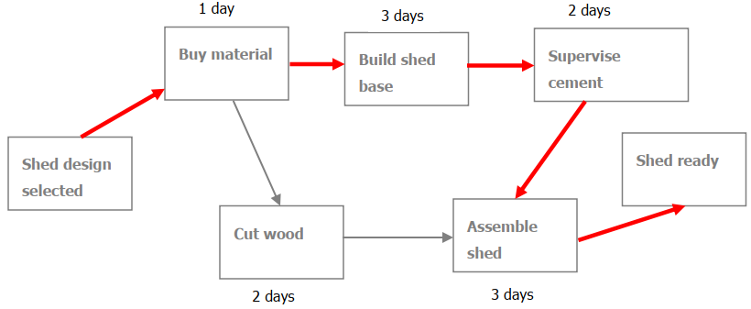

You can flesh out the following information from the above diagram

* The **Cut wood** activity can be carried out in parallel to the **Build shed base** & **Supervise cement hardening**
* The red arrows show what is known as Critical Path (Buy material -> Build shed base -> Supervise cement hardening -> Assemble shed). The Critical Path is the sequence of activities that takes up the most time to complete your project. Any delay in this sequence of activities will impact the overall timeframe of your project. Therefore, you should carefully monitor all activities on this path.

Keep in mind that the network diagram represents activities that must be done to complete the project. It is not a race to get from the first node to the last node. Every activity on the network diagram must be completed in order to finish the project. Note also that not every item on the WBS needs to be shown on the network diagram; only activities with dependencies need to be shown. However, some people like to have start and end milestones and to list every activity. It is a matter of preference. For large projects with hundreds of activities, it might be simpler to include only activities with dependencies on a network diagram. Sometimes it is enough to put summary tasks on a network diagram or to break down the project into several smaller network diagrams.

After you determine the reason for a dependency between activities (mandatory, discretionary, or external), you must determine the type of dependency.

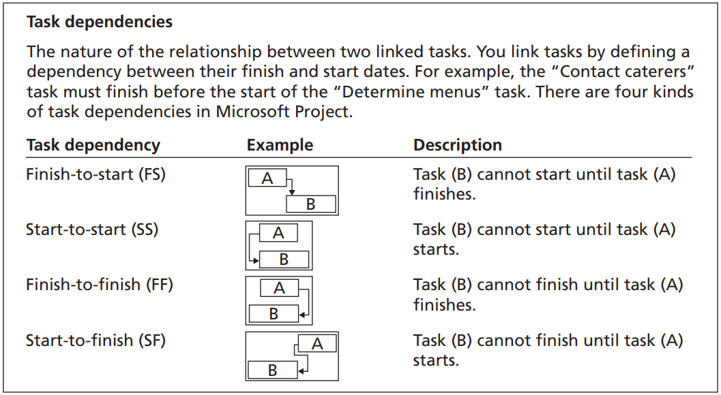

There are four types of dependencies or relationships between activities include

* **Finish-to-start**: A relationship in which the “from” activity or predecessor must finish before the “to” activity or successor can start. For example, you cannot provide user training until after software or a new system has been installed.
* **Start-to-start**: A relationship in which the “from” activity cannot start until the “to” activity or successor is started. For example, on IT projects, a group of activities might start simultaneously, such as the many tasks that occur when a new system goes live.
* **Finish-to-finish**: A relationship in which the “from” activity must be finished before the “to” activity can be finished. One task cannot finish before another finishes. For example, quality control efforts cannot finish before production finishes, although the two activities can be performed at the same time.
* **Start-to-finish**: A relationship in which the “from” activity must start before the “to” activity can be finished. This type of relationship is rarely used, but it is appropriate in some cases. For example, an organization might strive to stock raw materials just in time for the manufacturing process to begin. A delay in starting the manufacturing process should delay completion of stocking the raw materials. Another example would be a babysitter who wants to finish watching a young child but is dependent on the parent’s arrival. The parent must show up or “start” before the babysitter can finish the task.

## 5. Estimate Activity Resources

Before you can estimate the duration for each activity, you must have a good idea of the quantity and type of resources (people, equipment, and materials) that will be assigned to each activity. The nature of the project and the organization will affect resource estimates. Expert judgment, an analysis of alternatives, estimating data, and project management software are tools that can assist in resource estimating. The people who help determine what resources are necessary must have experience and expertise in similar projects and with the organization performing the project.

Important questions to answer when estimating activity resources include:

* How difficult will specific activities be on this project?
* Is anything unique in the project’s scope statement that will affect resources?
* What is the organization’s history in doing similar activities? Has the organization done similar tasks before? What level of personnel did the work?
* Does the organization have people, equipment, and materials that are capable and available for performing the work? Could any organizational policies affect the availability of resources?
* Does the organization need to acquire more resources to accomplish the work? Would it make sense to outsource some of the work? Will outsourcing increase or decrease the amount of resources needed and when they will be available?

Answering these questions requires important inputs such as a project’s schedule management plan, activity list, activity attributes, resource calendars, risk register, activity cost estimates, enterprise environmental factors, and organizational process assets such as policies regarding staffing and outsourcing. During the early phases of a project, the project team may not know which specific people, equipment, and materials will be available. For example, the team might know from past projects that a mix of experienced and inexperienced programmers will work on a project. The team might also be abl to approximate the number of people or hours needed to perform specific activities.

It is important to thoroughly brainstorm and evaluate alternatives related to resources, especially on projects that involve people from multiple disciplines and companies. Because most projects involve many human resources and the majority of costs are for salaries and benefits, it is often effective to solicit ideas from different people to help develop alternatives and address resource-related issues early in a project. The resource estimates should also be updated as more detailed information becomes available.

The main outputs of the resource estimating process include a list of activity resource requirements, a resource breakdown structure, and project documents updates. For example, if junior employees will be assigned to many activities, the project manager might request that additional activities, time, and resources be approved to help train and mentor those employees.

## 6. Estimate Activity Duration

After working with key stakeholders to define activities, determine their dependencies, and estimate their resources, the next process in project time management is to estimate the duration of activities. It is important to note that **duration** includes the actual amount of time worked on an activity plus elapsed time. For example, even though it might take one workweek or five workdays to do the actual work, the duration estimate might be two weeks to allow extra time needed to obtain outside information. The people or resources assigned to a task will also affect the task duration estimate. As another example, if someone asked for an estimate of when you plan to finish reading a particular book, you might give an answer of two months. Two months would be the duration estimate, even if you only plan to spend 20 hours actually reading the book, which would be the effort estimate. If other people (resources) were asked to provide duration and effort estimates for the same task, theirs would be different.

Do not confuse duration with **effort**, which is the number of workdays or work hours required to complete a task. A duration estimate of one day could be based on eight hours of work or 80 hours of work, assuming that multiple people are working on a task that day. Duration relates to the time estimate on a calendar, not the effort estimate. Of course, the two are related, so project team members must document their assumptions when creating duration estimates and update the estimates as the project progresses. The people who will actually do the work, in particular, should have a lot of say in these duration estimates because their performances will be evaluated based on their ability to meet the estimates. If scope changes occur on the project, the duration estimates should be updated to reflect those changes. It is also helpful to review similar projects and seek the advice of experts in estimating activity durations.

There are several inputs to activity duration estimates, including the schedule management plan, activity list, activity attributes, activity resource requirements, resource calendars, project scope statement, risk register, resource breakdown structure, enterprise environmental factors, and organizational process assets. In addition to reviewing past project information, the team should review the accuracy of the duration estimates thus far on the project. For example, if team members find that all of their estimates have been much too long or short, they should update the estimates to reflect what they have learned. One of the most important considerations in making activity duration estimates is the availability of resources, especially human resources. What specific skills do people need to do the work? What are the skill levels of the people assigned to the project? How many people are expected to be available to work on the project at any one time?

The outputs of activity duration estimates include the estimates themselves and project documents updates. Duration estimates are often provided as a discrete number, such as four weeks; as a range, such as three to five weeks; or as a three-point estimate. Let’s look at estimating techniques that may be used on a project as in below paragraphs

One-Point Estimating When estimating time using a one-point estimate, the estimator submits one  
estimate per activity. For example, the person doing the estimating says that the activity will take five weeks. The time estimate may be based on expert judgment or historical information, or it could be just a guess. As a result, this technique can be problematic.

Although one-point estimating is often not the best method to use, it is an easy way to illustrate how to  
draw network diagrams and find the critical path.

Analogous Estimating (Top-Down): uses expert judgment and historical information to predict the future. Analogous estimating can also be used at the activity level, if the activity has been done on previous projects and if there is substantial historical data to support the accuracy of such an estimate. (For example, the last two times this activity was completed each took three days; since we have no other information to go on, we will use three days as the estimate for this activity and review the estimate when more details become available).

Parametric Estimating involves creating a mathematical equation using data from historical records or other sources, such as industry requirements or standard metrics, to create estimates. The technique analyzes relationships between historical data and other variables to estimate duration or cost. It can be applied to some or all the activities within a project. For example, when estimating activity duration, the estimator may use measures such as time per line of code, time per linear meter, or time per installation. When used in cost estimating, the measures include cost as one of the variables. So the measures would be cost per line of code, cost per linear meter, etc.

Three-Point Estimating: statistically, there is a very small probability of completing a project on exactly any one date. As we know, things do not always go according to plan. Therefore, it is often best to state estimates in a range using three-point estimates. Analyzing what could go right (opportunities) and what could go wrong (threats) can help estimators determine an expected range for each activity. By analyzing this range of time or cost estimates, the project manager can better understand the potential variation of the activity estimates. With the three-point technique, estimators give an optimistic (O), pessimistic (P), and most likely (M) estimate for each activity. The optimistic estimate is based on a best-case scenario, while the pessimistic estimate is based on a worst-case scenario. The most likely estimate, as you might expect, is based on a most likely or expected scenario. Three-point estimating allows more consideration of both the uncertainty of estimating and the risks associated with the activities being estimated. A wide range between the optimistic and pessimistic estimates can indicate uncertainty and therefore risk associated with the activity.

Ultimately, three-point estimates can be used to calculate a risk-based expected duration estimate for an activity by taking either a simple average or a weighted average of three estimates.

* Simple average: Estimated Duration = (P + M + O)/3
* Beta Distribution (Weighted Average or PERT method): Estimated Duration = (P + 4*M + O)/6

## 7. Develop Schedule

Schedule development uses the results of all the preceding processes to determine the start and end dates of the project and its activities. It is iterative and can occur many times over the life of the project (at least once per project life cycle phase on a large project) before a project schedule is finalized.

The ultimate goal of developing a realistic project schedule is to provide a basis for monitoring project progress for the time dimension of the project. The main outputs of this process are the baselined project schedule where it is important for the PM to keep in mind any “Assumptions” and “Constraints” identified in the Project Charter and/or Plan, and how they may impact the timeline. As well, risks and issues should be taken into consideration when creating the project schedule.

### a. Critical Path Method

Critical Path Method involves determining the longest duration path through the network diagram, the earliest and latest an activity can start, and the earliest and latest it can be completed. To use this method, you need to understand the following basic concepts

### b. Schedule Compression

One of the most common problems on projects is an unrealistic timeframe. This problem can arise during project planning when management or the customer requires a completion date that cannot be met, or during project executing when the project manager needs to bring the project back in line with the schedule baseline or adjust the project for changes.

Many project managers blame their sponsors or executives for unrealistic schedules, but project managers have a professional responsibility to push back, present options, and make sure the project is achievable by properly planning the project and using schedule network analysis techniques such as schedule compression.

Also keep in mind that schedule compression is a way to utilize float by fast tracking activities that are on  
the critical path. This means adjusting the network diagram so critical path activities that were originally  
planned to be completed in a series are re-planned to be done in parallel. As we discuss below, fast tracking can save time, but it also adds risk to the project. During project planning, schedule compression can help a project manager determine if the desired completion date can be met and, if not, what can be changed to meet the requested date. This isn't always possible, but we try.

*Fast Tracking* This technique involves taking critical path activities that were originally planned in a  
series and doing them instead in parallel for some or all of their duration. Fast tracking often  
results in rework, usually increases risk, and requires more attention to communication.

*Crashing* This technique involves adding or adjusting resources in order to compress the schedule  
while maintaining the original project scope. Crashing, by definition, always results in increased costs, and  
may increase risk. It trades time for money.

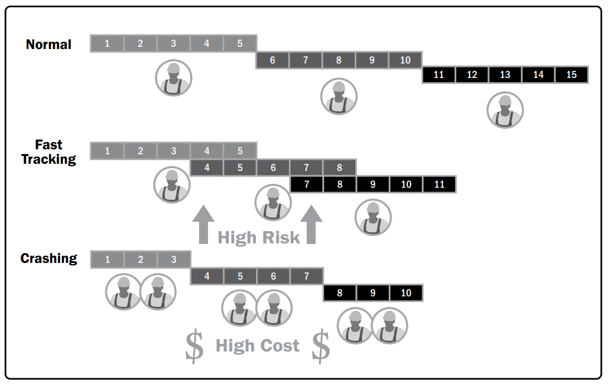

In the real world, many project managers use the network diagram to manage the day-to-day operations of the project and to make adjustments when changes occur.

### b. Resource Optimization

Resource optimization is used to adjust the start and finish dates of activities to adjust planned resource use to be equal to or less than resource availability. Examples of resource optimization techniques that can be used to adjust the schedule model due to demand and supply of resources include but are not limited to:

* **Resource leveling** a technique in which start and finish dates are adjusted based on resource constraints with the goal of balancing the demand for resources with the available supply. Resource leveling can be used when shared or critically required resources are available only at certain times or in limited quantities, or are over-allocated, such as when a resource has been assigned to two or more activities during the same time period, or there is a need to keep resource usage at a constant level. Resource leveling can often cause the original critical path to change. Available float is used for leveling resources. Consequently, the critical path through the project schedule may change.
* **Resource smoothing** a technique that adjusts the activities of a schedule model such that the requirements for resources on the project do not exceed certain predefined resource limits. In resource smoothing, as opposed to resource leveling, the project’s critical path is not changed and the completion date may not be delayed. In other words, activities may only be delayed within their free and total float. Resource smoothing may not be able to optimize all resources.

### d. Agile Release Planning

Agile release planning provides a high-level summary timeline of the release schedule (typically 3 to 6 months) based on the product roadmap and the product vision for the product’s evolution. Agile release planning also determines the number of iterations or sprints in the release, and allows the product owner and team to decide how much needs to be developed and how long it will take to have a releasable product based on business goals, dependencies, and impediments.

Since features represent value to the customer, the timeline provides a more easily understood project schedule as it defines which feature will be available at the end of each iteration, which is exactly the depth of information the customer is looking for.

Below figure shows the relationship among product vision, product roadmap, release planning, and iteration planning

